Java Backend Interview Assignment:

Import Postman Collection Link : <https://api.postman.com/collections/32312658-fec73ca1-0fde-47c0-a142-f22229910774?access_key=PMAT-01HM2WGVYGXY69B3SNB0277DFB>

1. Create a Java Spring Boot Application.

2. Project Structure is required for ease of maintainability and readability.

Navigate to <https://start.spring.io>,

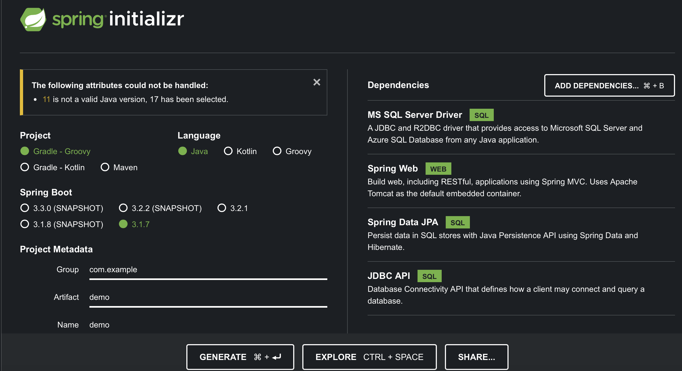

Select Gradle, Preferred Spring Boot Version, add needed dependencies, Then click GENERATE (CMD + ENTER).

It will generate a demo zip folder, extract it.

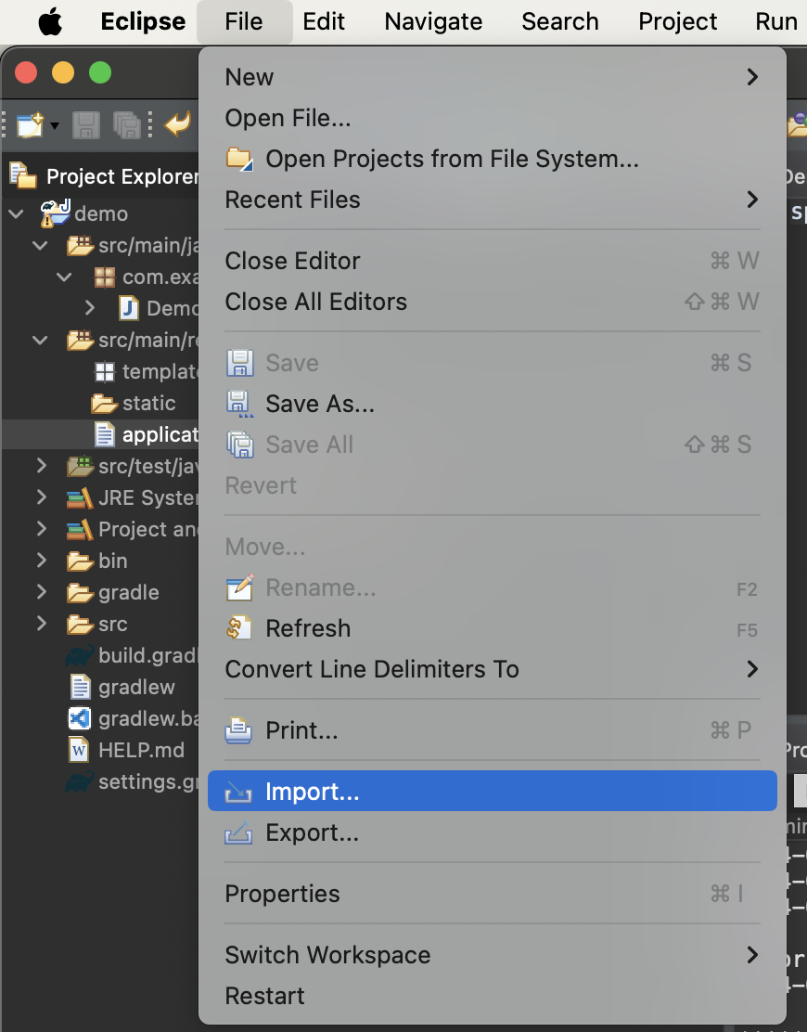

Open you IDE (Mine is Eclipse), click Import > Gradle > Existing Gradle Project > Extracted demo file > Finish button.

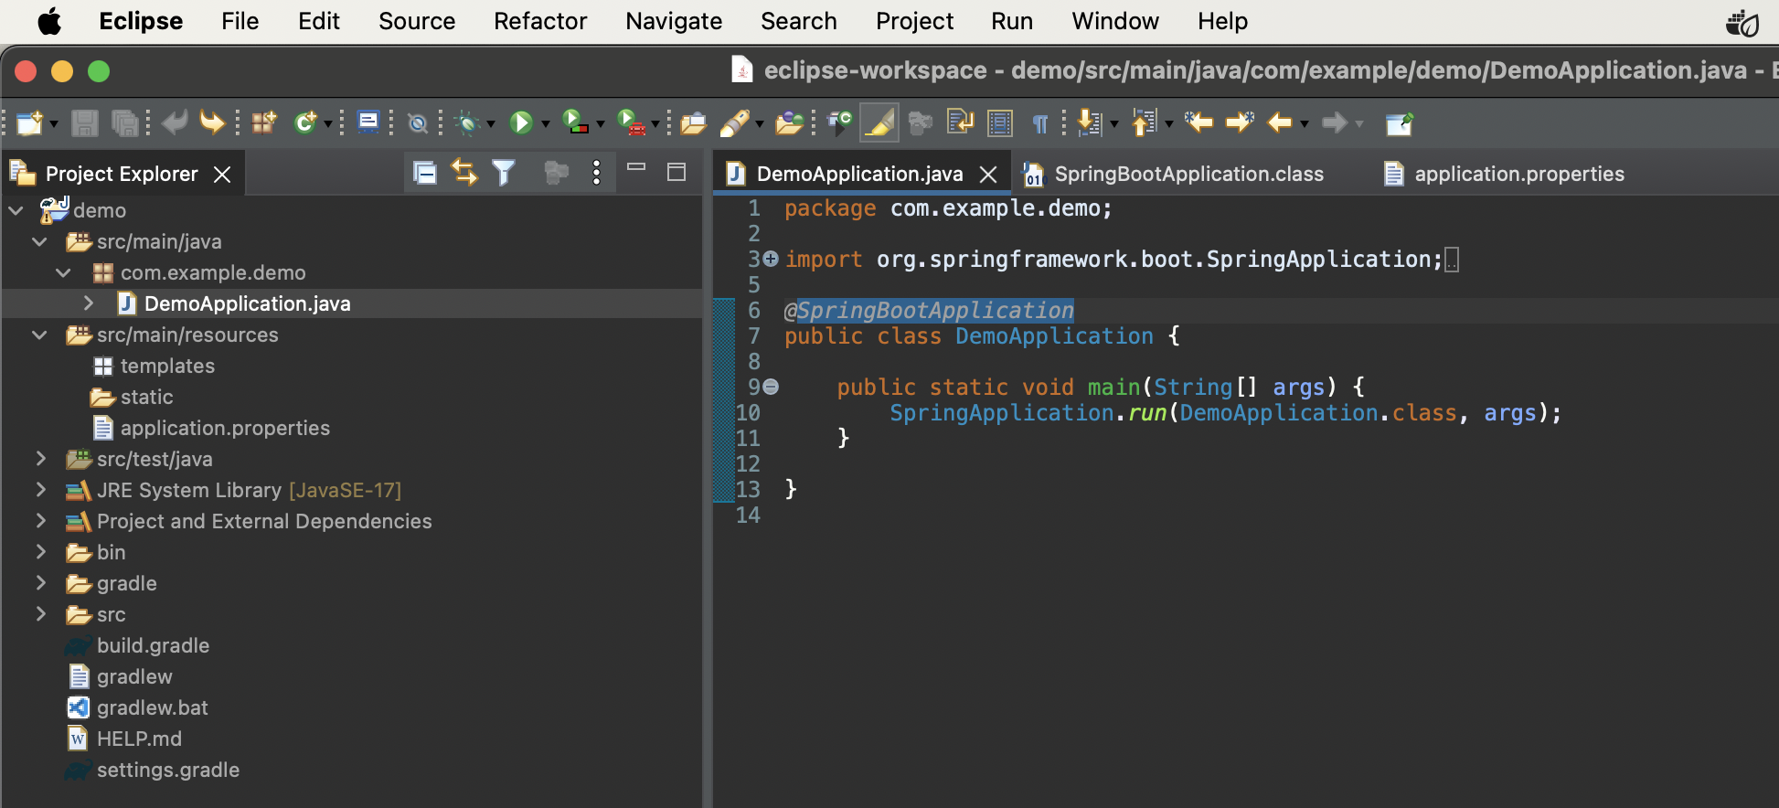

You should saw smtg like this.

At this step, since I haven’t start configured DataSource, it might start failed.

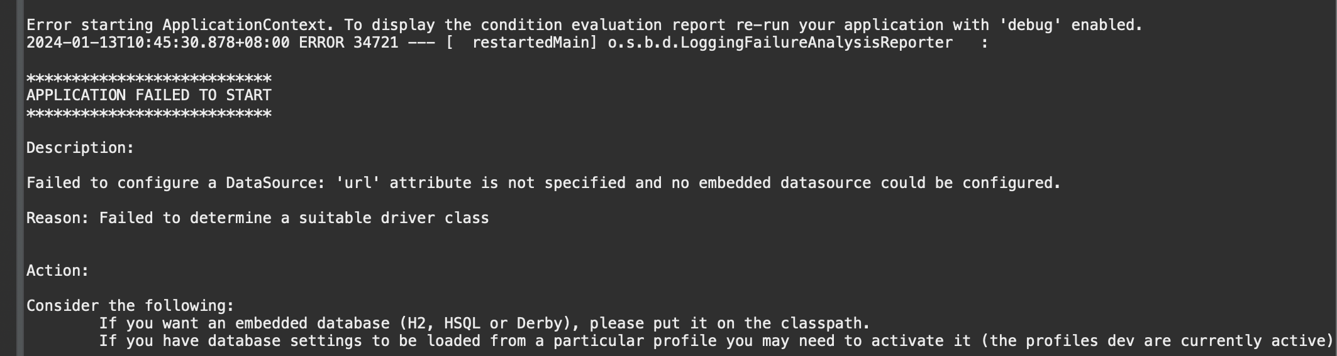

<Jump to Step 5 in order to have a look on how to setup db.>

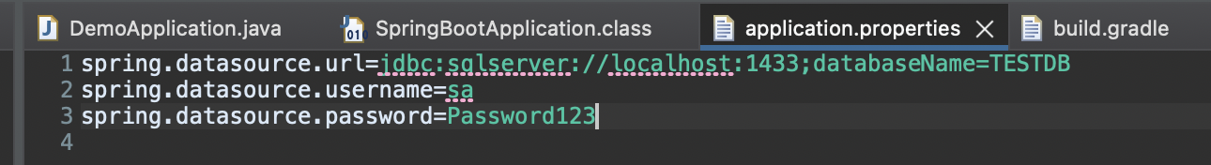

Since DB setup done, navigate to src/main/resources/application.properties.

Enter info needed. For url, get from below diagram.

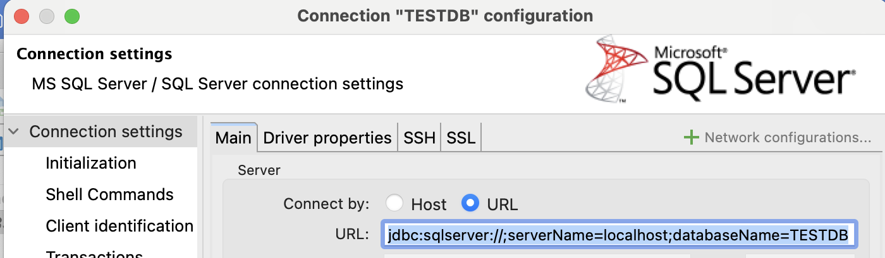

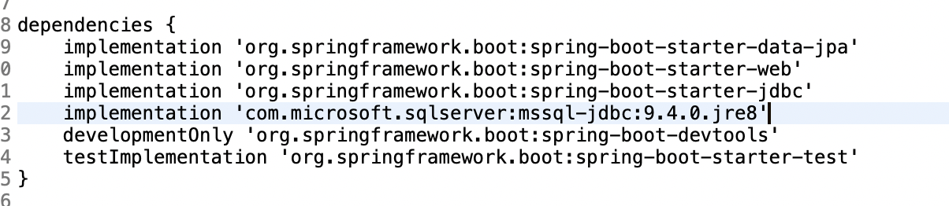

Add “implementation 'com.microsoft.sqlserver:mssql-jdbc:9.4.0.jre8'”into build.gradle.

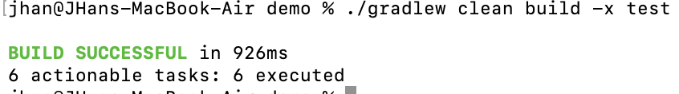

Execute: ./gradlew clean build -x test

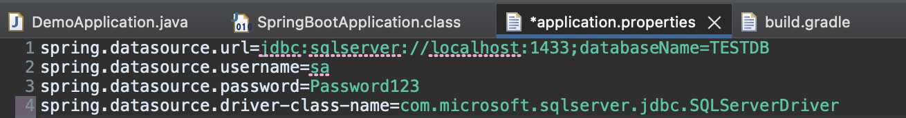

Add last line

spring.datasource.driver-class name=com.microsoft.sqlserver.jdbc.SQLServerDriver

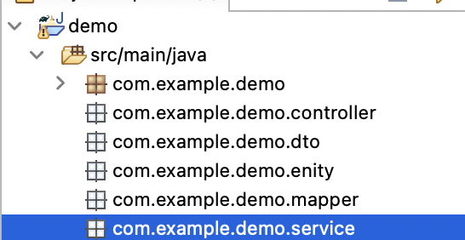

Open few packages that might needed.

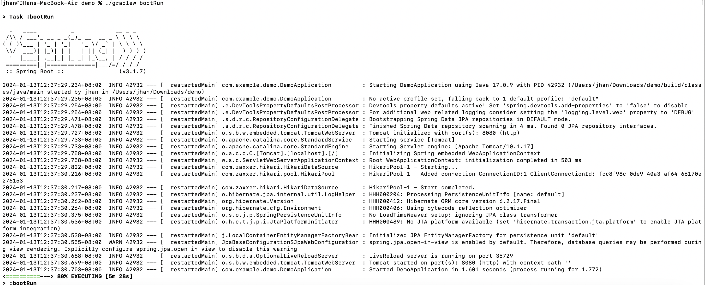

Try cmd: ./gradlew bootRun

4. Each api required to log REQUEST & RESPONSE info into logs file.

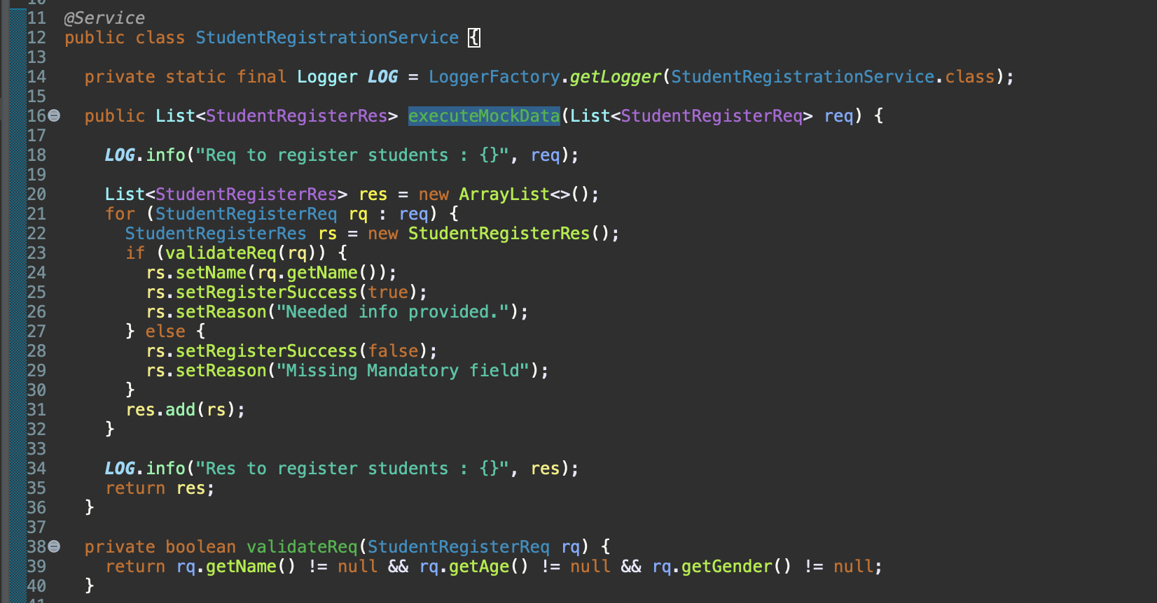

Line 18 & Line 34 log out REQUEST & RESPONSE.

5. Your project able connect to database, preferred with MSSQL database (Using Local Machine DB, DB name: TESTDB).

- @transactional is required implement in the project. (For http Methos: INSERT, UPDATE, GET method)

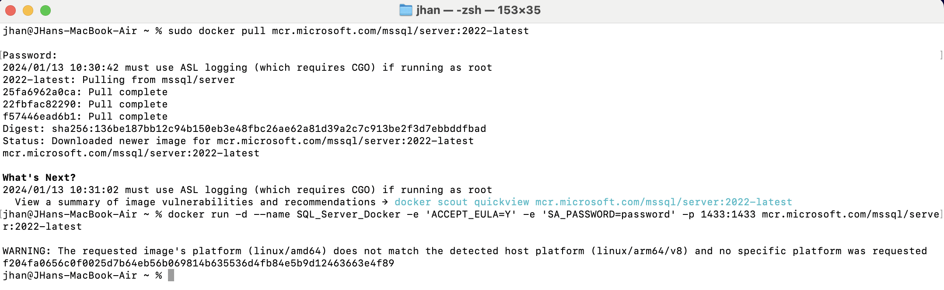

To fix it, setup MSSQL database 1st. (Since my env is MACOS, so I prefer docker since it support in different environment)

Cmd: sudo docker pull mcr.microsoft.com/mssql/server:2022-latest

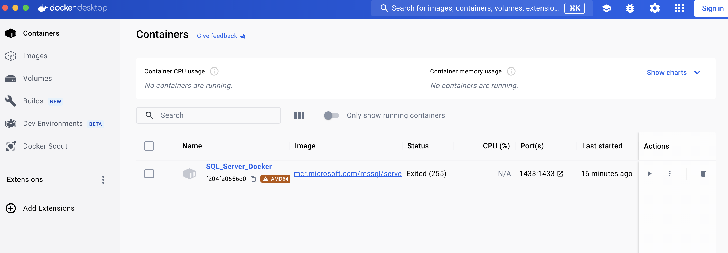

Open your docker, you should saw a “SQL_Server_Docker”.

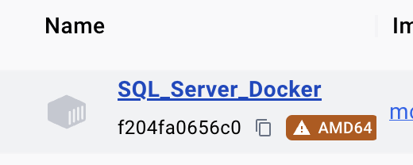

Click this to enter this container.

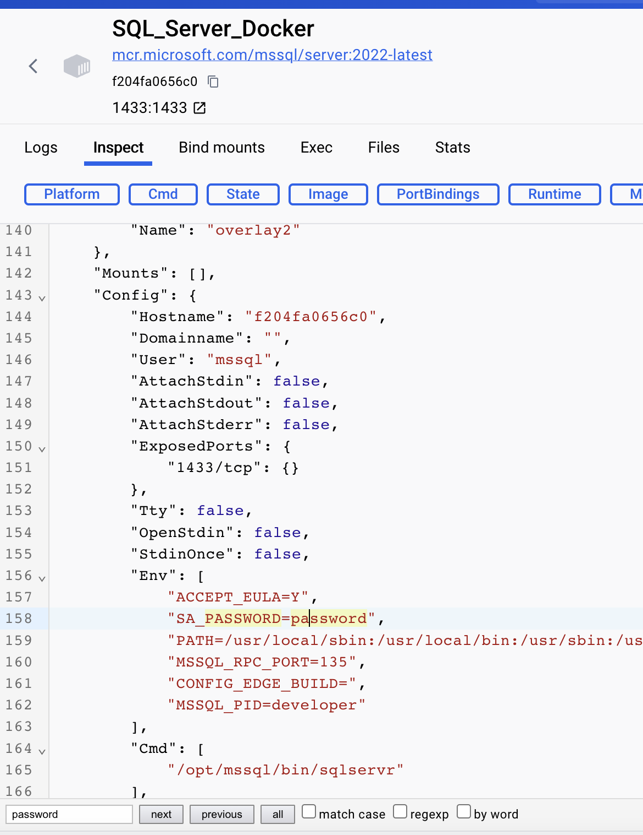

Find key word “SA_PASSWORD”, you will saw ur current password is “password”,

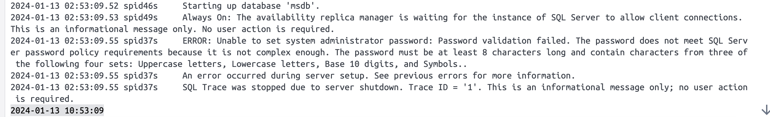

If you use the default password, you might start fail as it does not met SQL Server password policy.

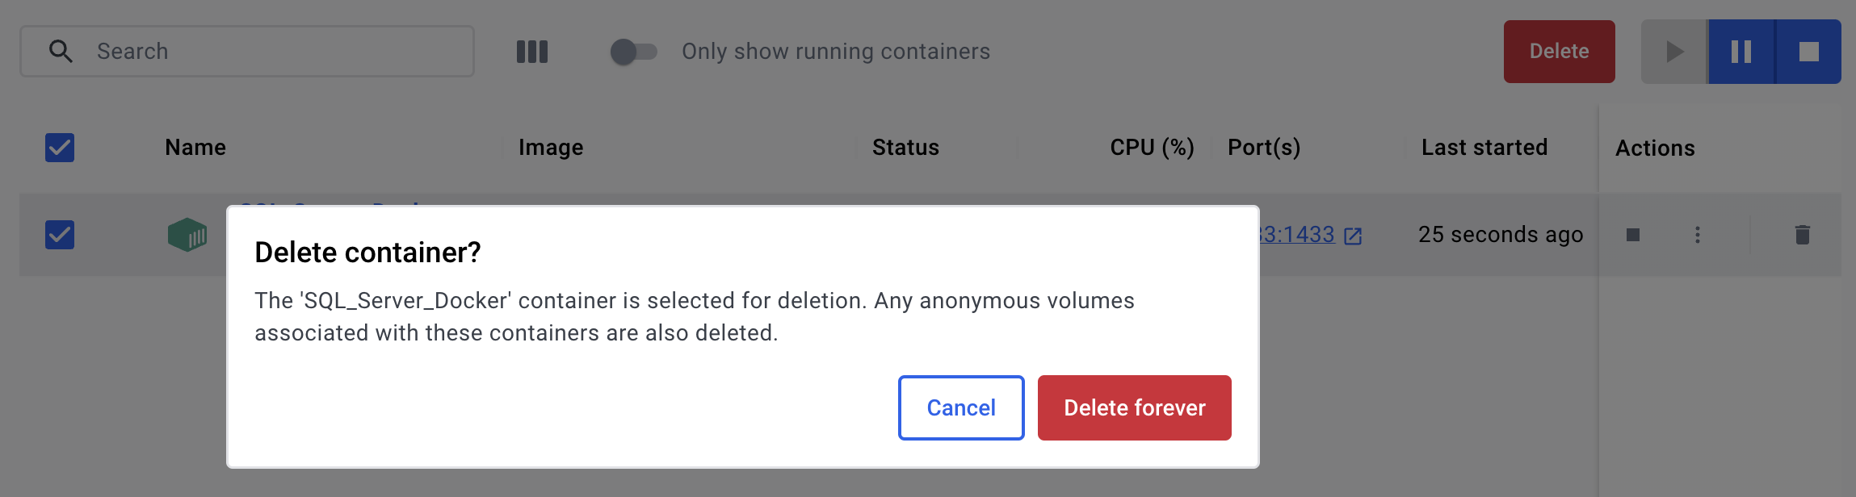

So, delete it.



Execute cmd,

docker run -d --name SQL_Server_Docker -e 'ACCEPT_EULA=Y' -e 'SA_PASSWORD=Password123' -p 1433:1433 mcr.microsoft.com/mssql/server:2022-latest

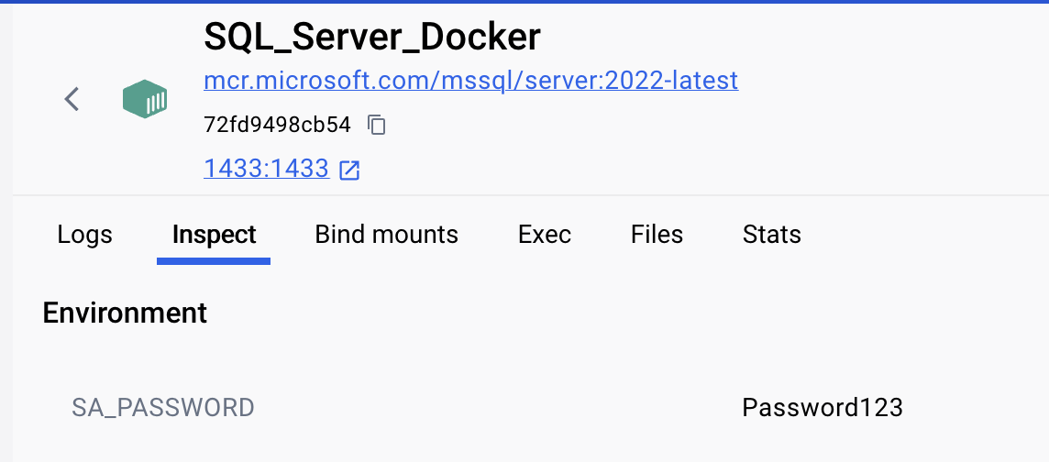

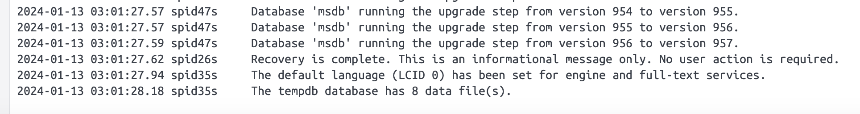

U will saw the password has been changed and able to start now.

Install sql cli via below cmd.

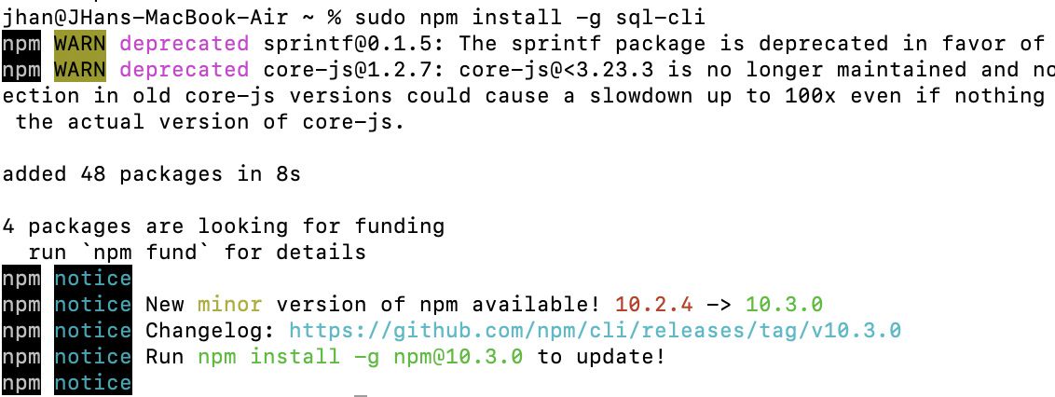

sudo npm install -g sql-cli

Test Connectivity,

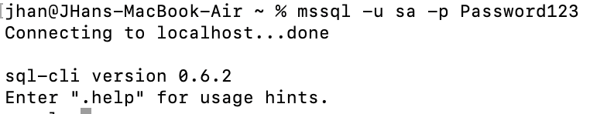

via cmd: mssql -u sa -p <SA_Password> mssql -u sa -p Password123

For better illustration purpose, gui interface will be easier. In my case, use <https://dbeaver.io/download/> (dbeaver).

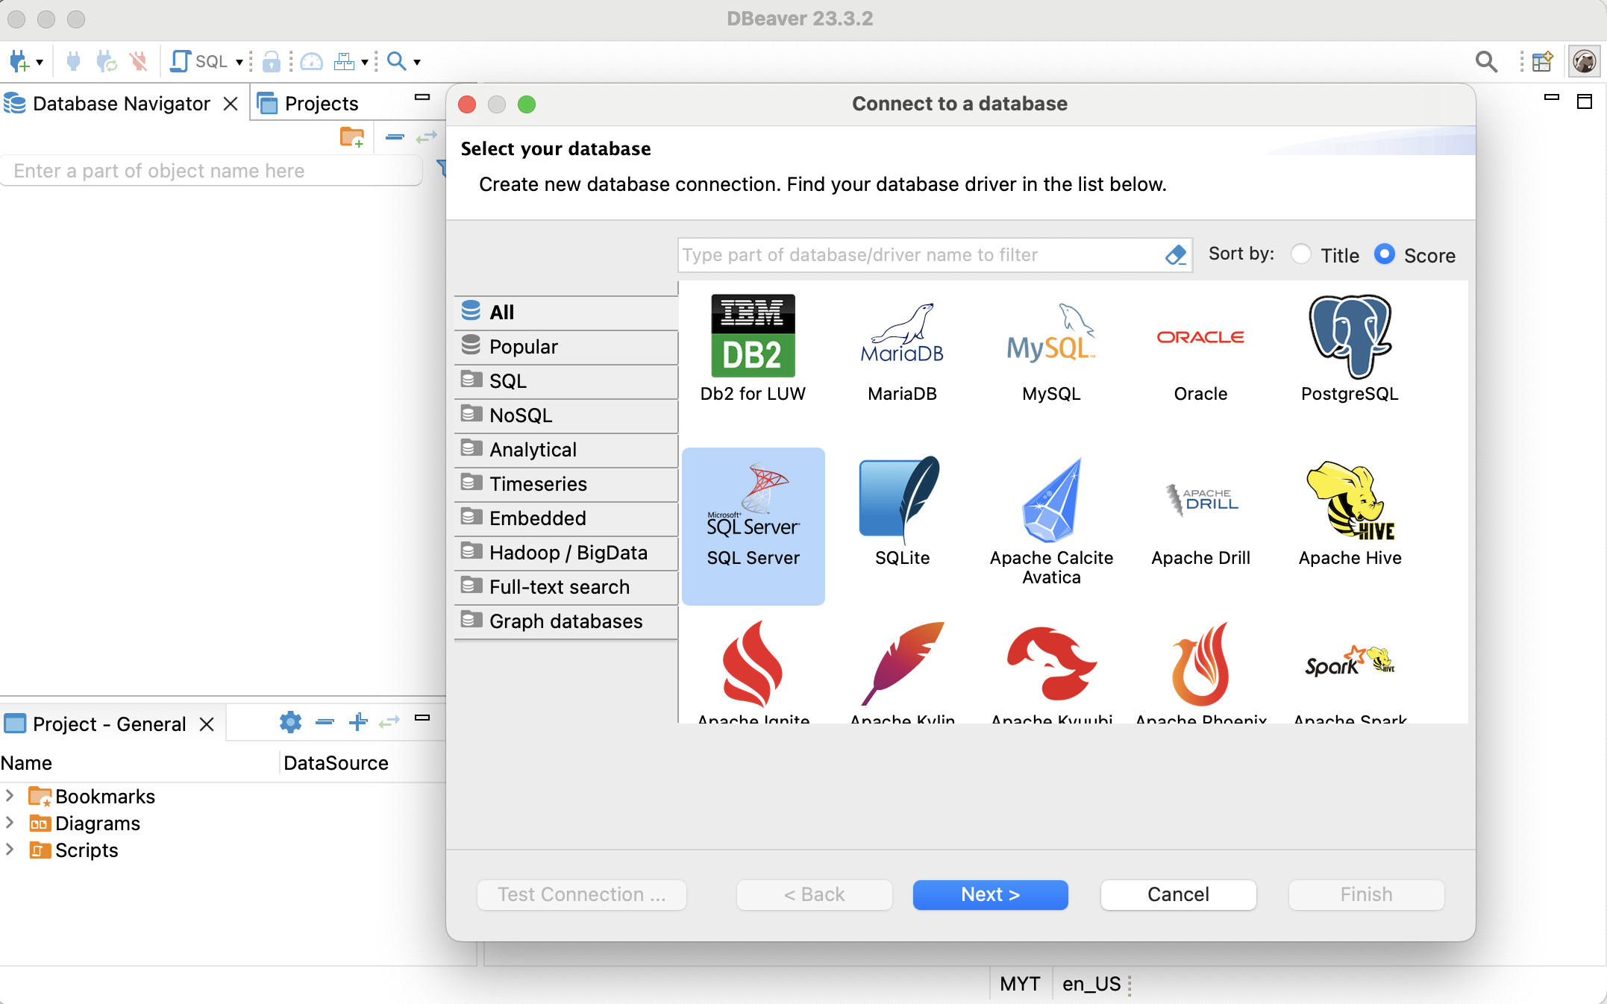

Select MSSQLServer.

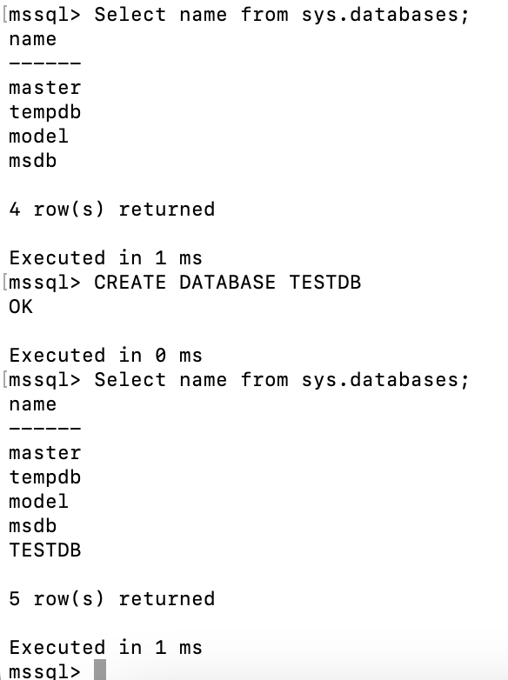

Use cmd: CREATE DATABASE TESTDB to create.

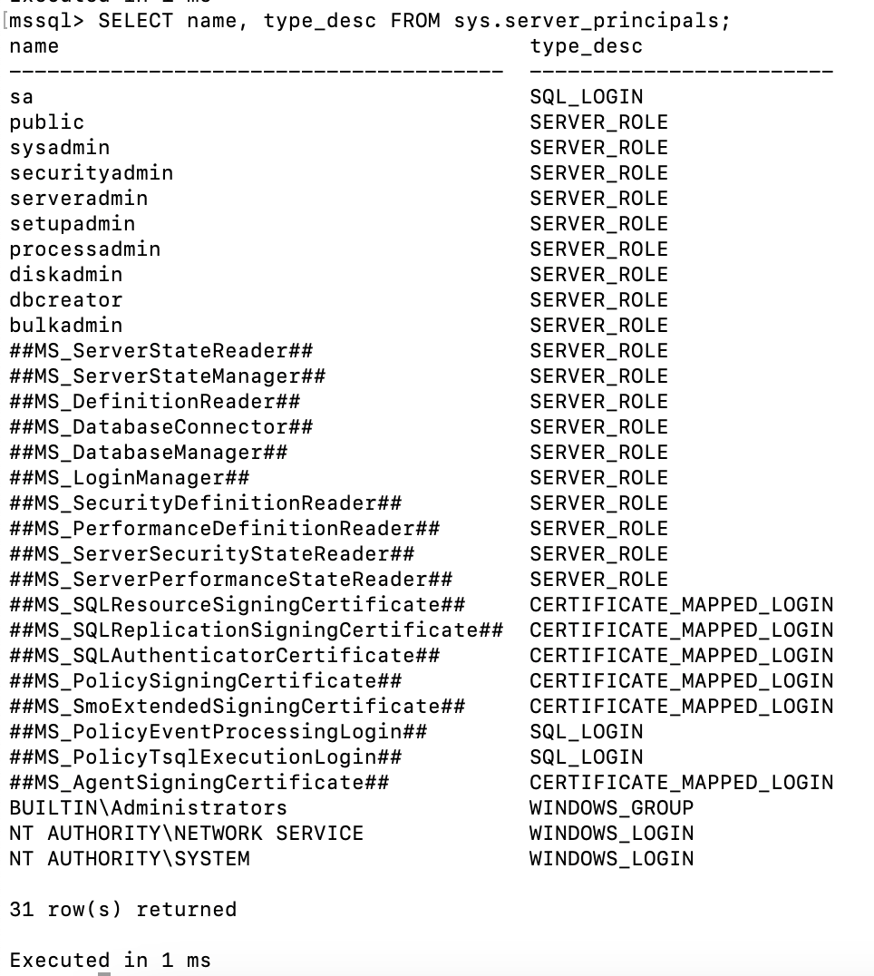

Use cmd: SELECT name, type_desc FROM sys.server_principals to get list of name. (Which means yr login username is “sa”).

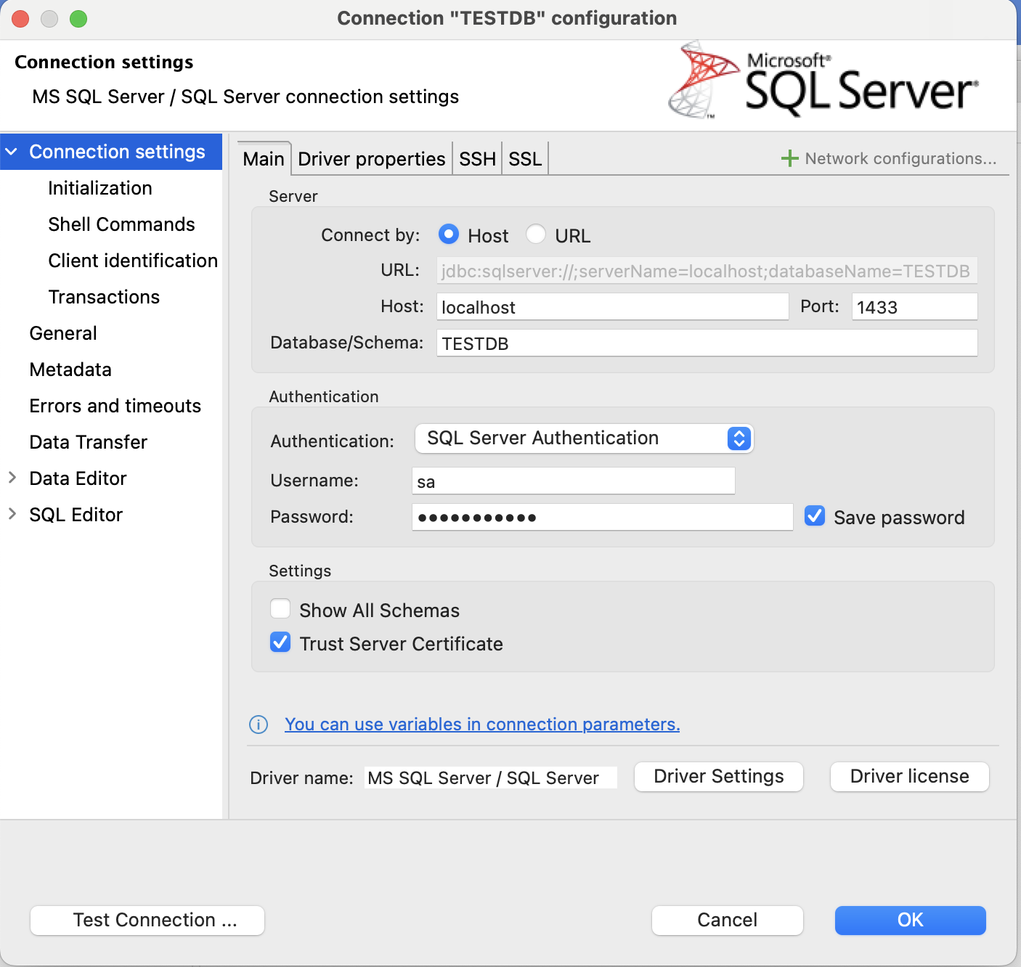

Database TESTDB, Username sa, password same as SA_PASSWORD (Password123), tick “Trust Server Certificate”.

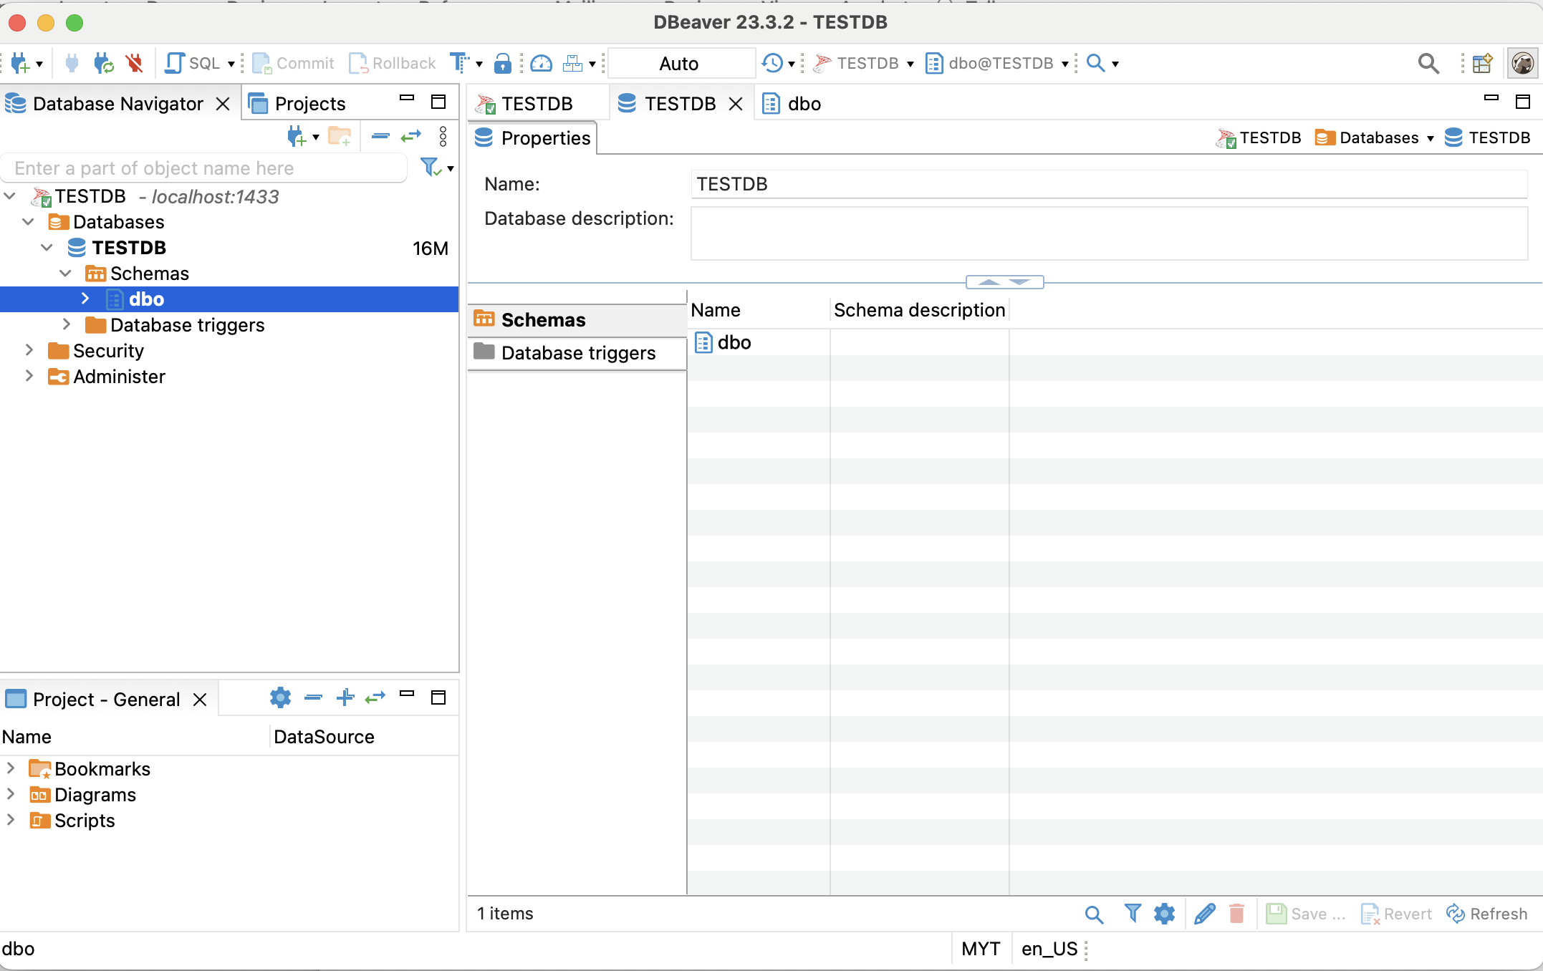

Connected successfully.

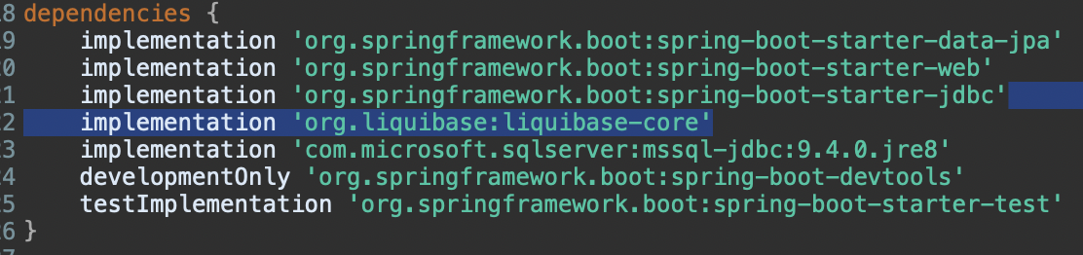

In real life, there’s many developers might commit sql script. For ease to maintain + traceback, integrate spring boot with Liquibase is a good way to avoid mistakes. (Add implementation into build.gradle)



Direct bootrun might fail due to db.changelog-master.yaml is missing.

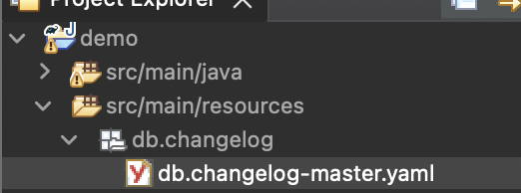

Create it. (It must be this path, or else need to change in application.properties)

This file is to include files that u want to execute.

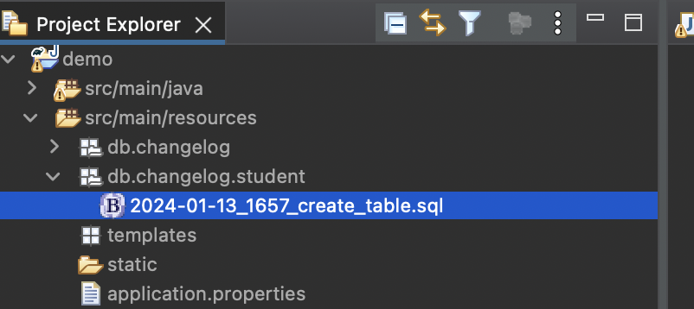

Create sql file.

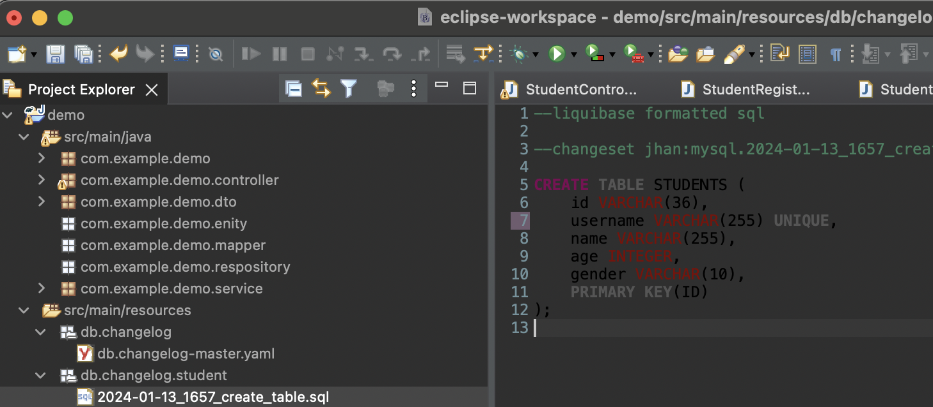

Create table Script.

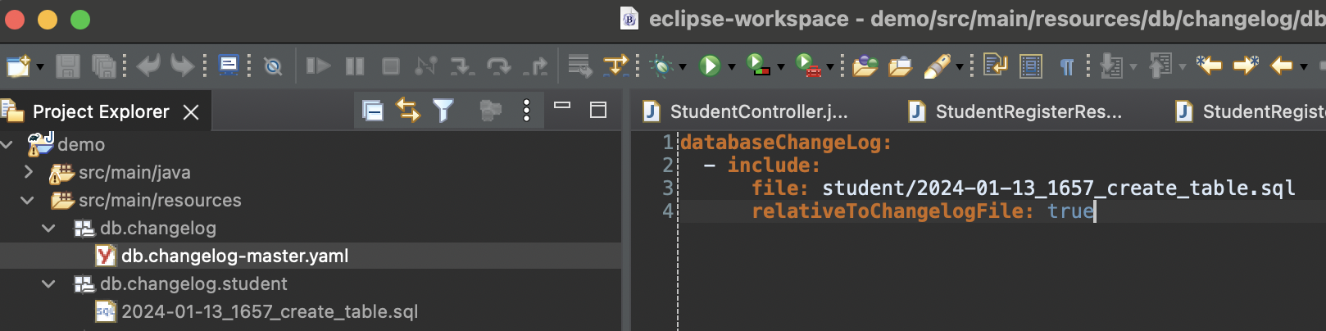

Included into master yaml.

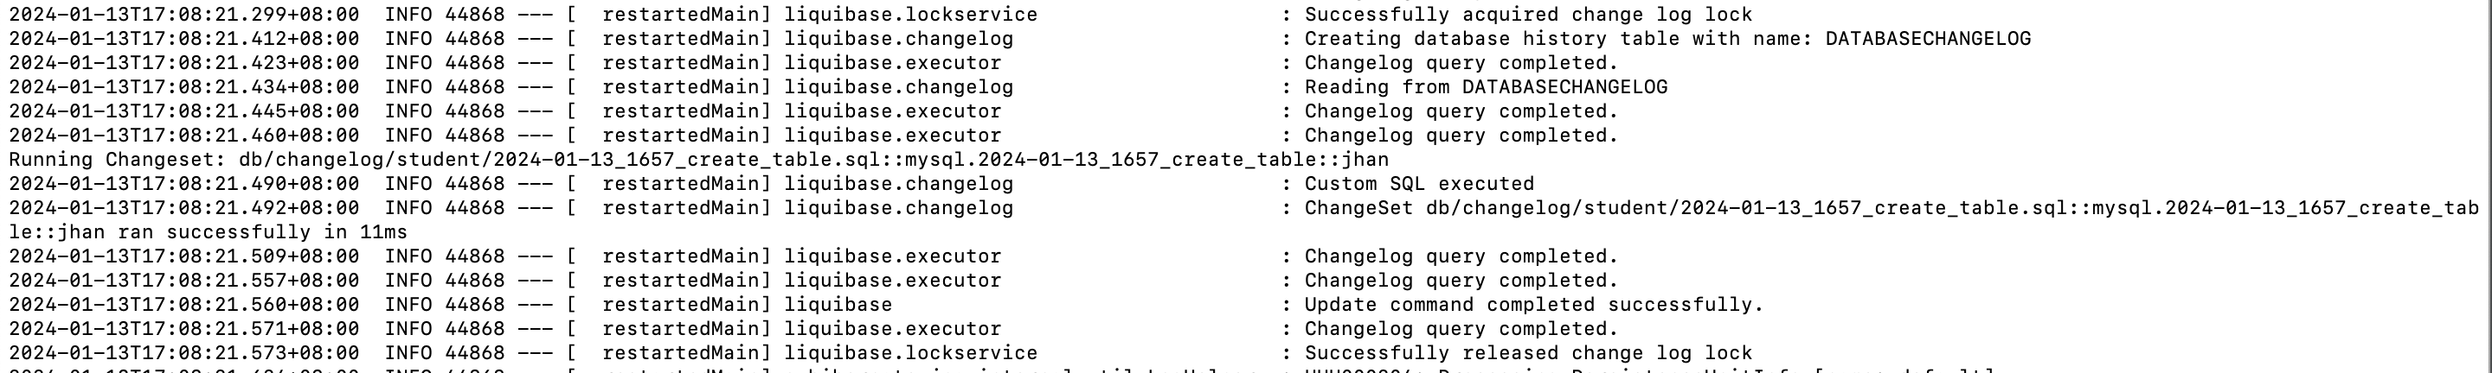

During ./gradlew bootRun, u could saw that sql has been execute.

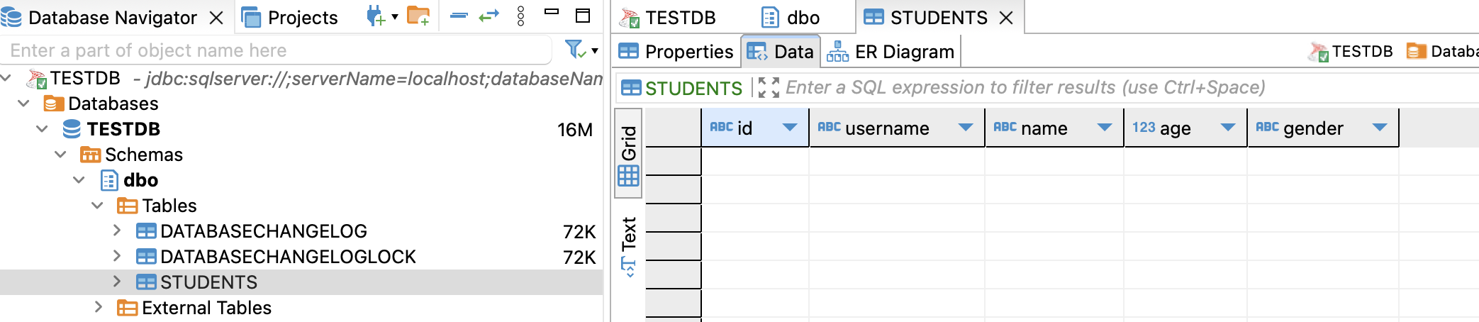

Table has been created successfully.

Insert Data, fire <http://localhost:8080/public/v1/test/student-registration>.

Code level got handle validate duplicate username, will throw error if check from db get duplicated.



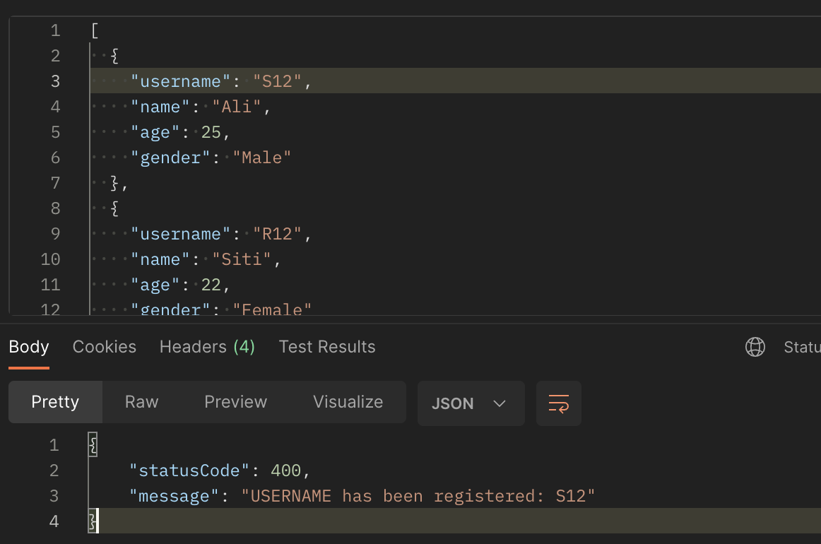

Since we registered username “S12”, if we registered again, it will throw bad request with custom error. Even we register few users at one api, if one of the usernames has been duplicated, since we added @Transactional, this insert action will be rollback.

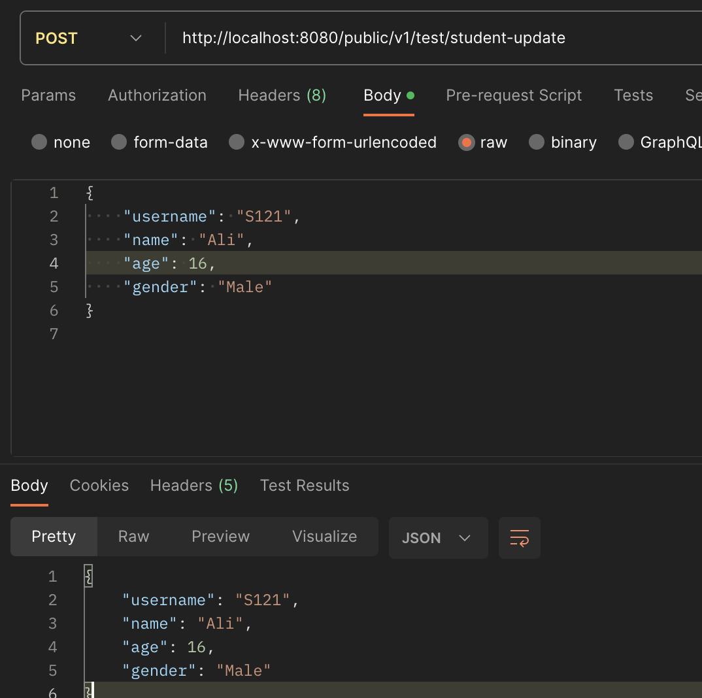

Fire endpoint http://localhost:8080/public/v1/test/student-update to update db.

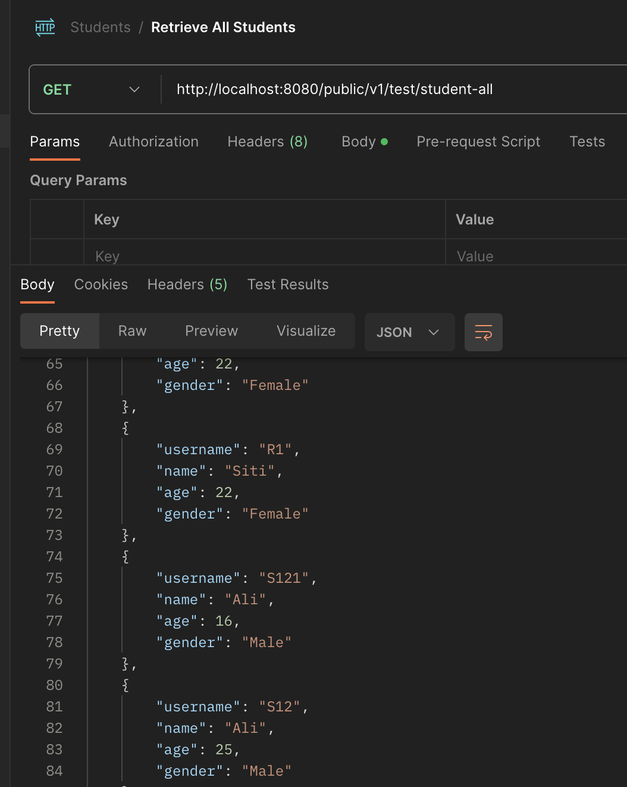

Fire endpoint <http://localhost:8080/public/v1/test/student-all> to get all info from db.

6. Explore 1 GET method api with Pagination (Each Page 10 records)

Use SpringFramework Pageable object.

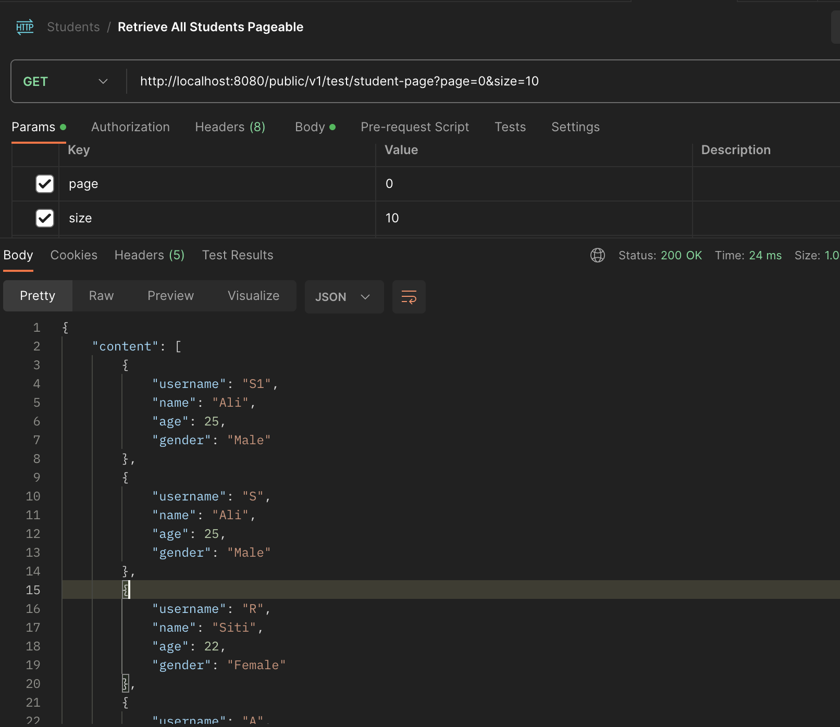

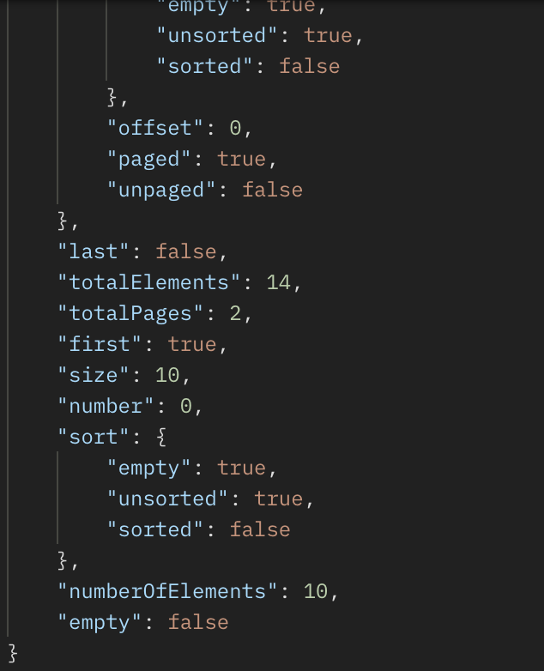

Fire api <http://localhost:8080/public/v1/test/student-page?page=0&size=10>.

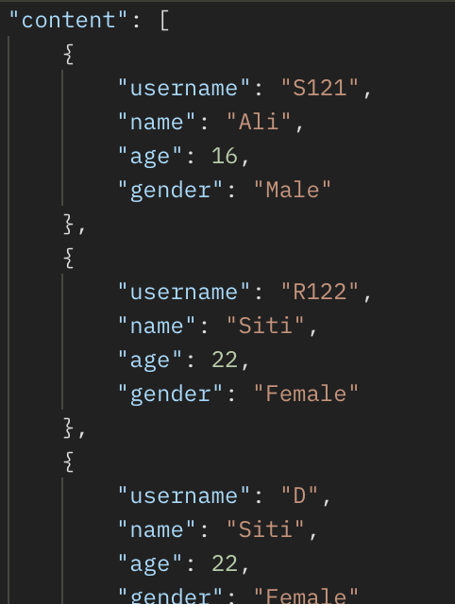

By using pageable by spring, it supports sorting features by adding query params such as (&sort=age)

7. Explore an api which will nested calling another api from 3rd party.

Example: Postman/Client > Your API Endpoint > calling another api

Try to fire to <https://playground.mockoon.com/movies>. It will return list of movies.

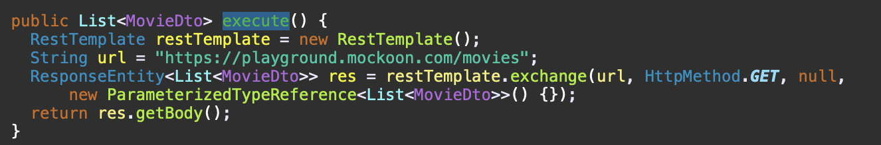

Use SpringRestTemplate.

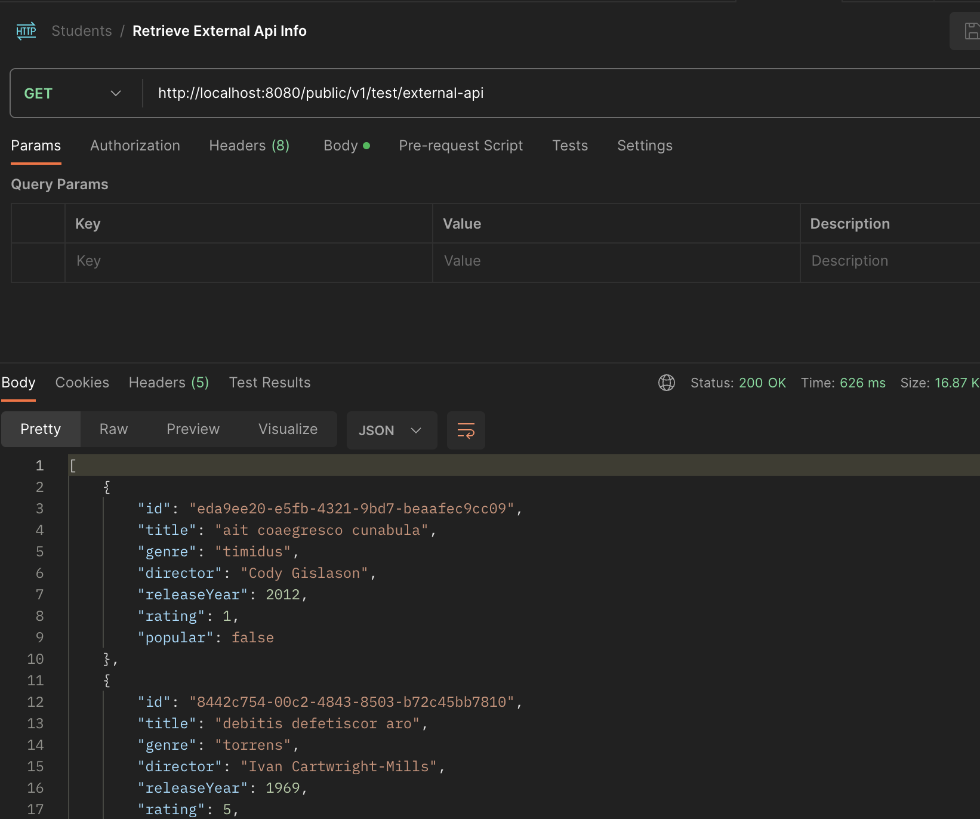

U will get list of movies.

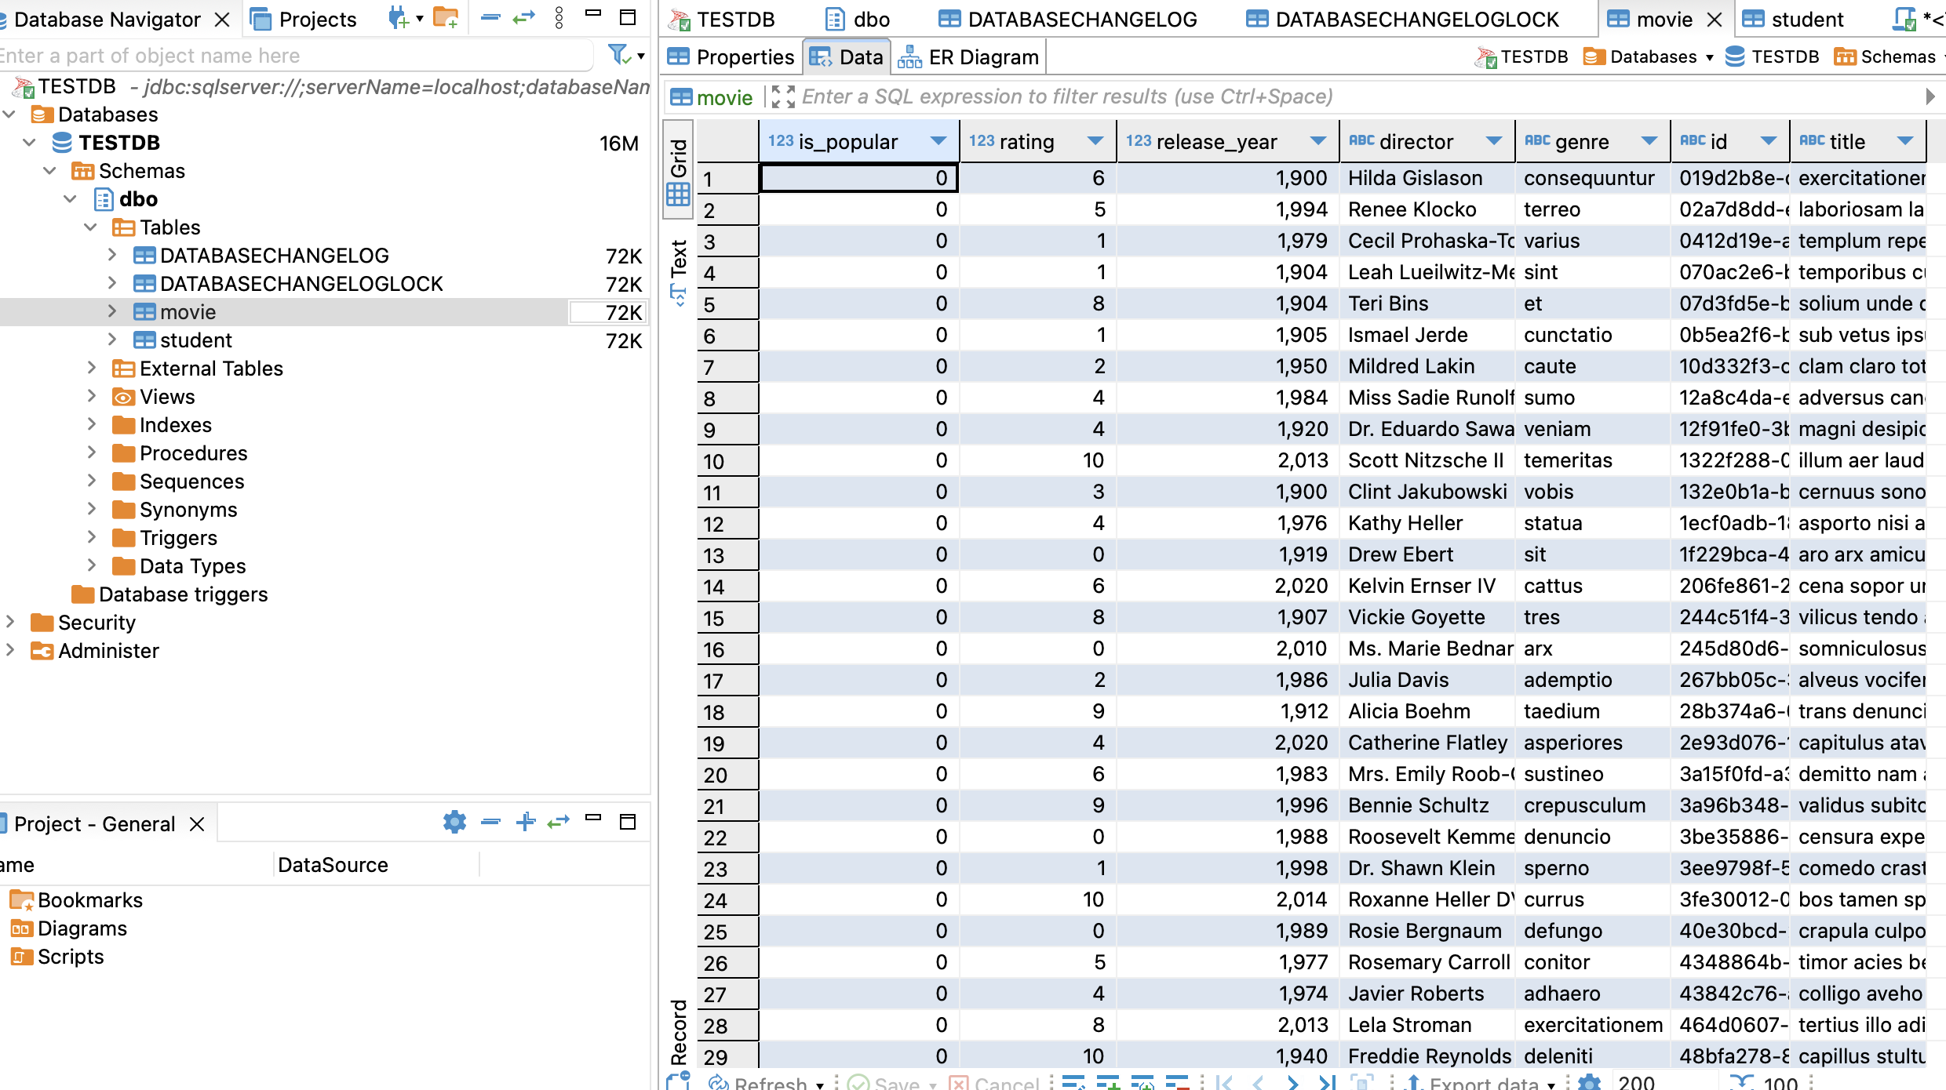These info will be store into db.